***Experiment :6***

**Create a Pipeline using Jenkins File**

Name: Aditya agarwal  
Roll no: R171218007  
Sap id: 500069294

Go to Jenkins ,enter a new item and select pipeline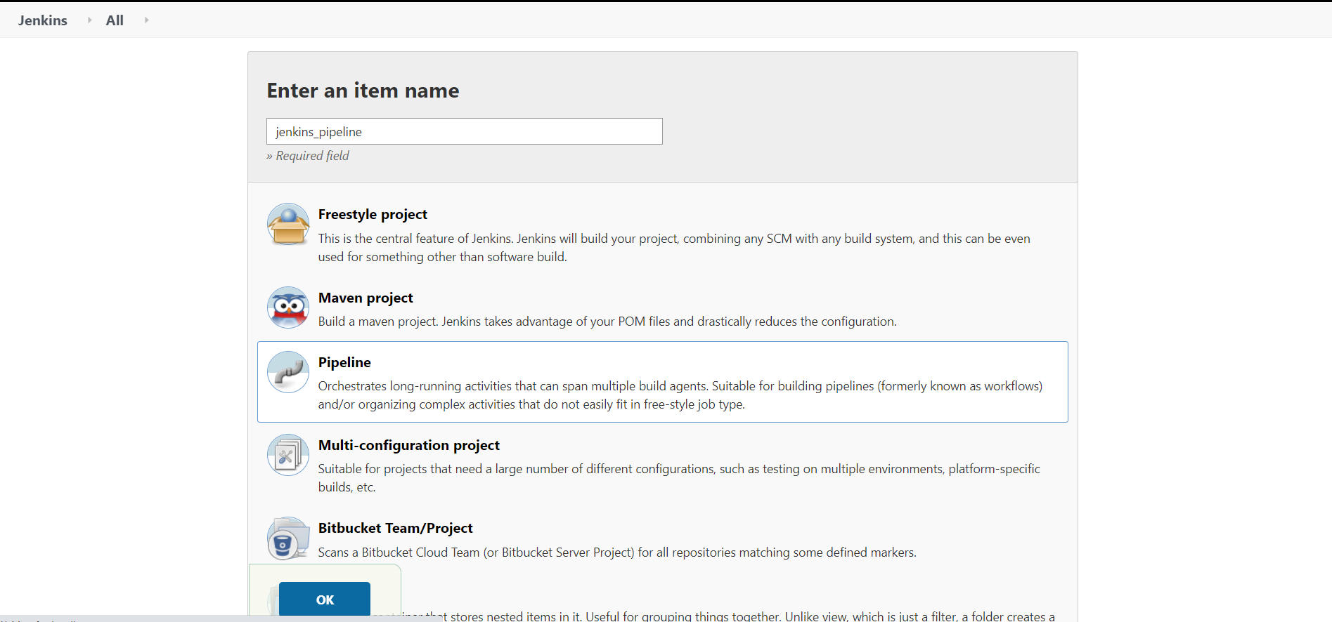

Select git in SCM and add repo link

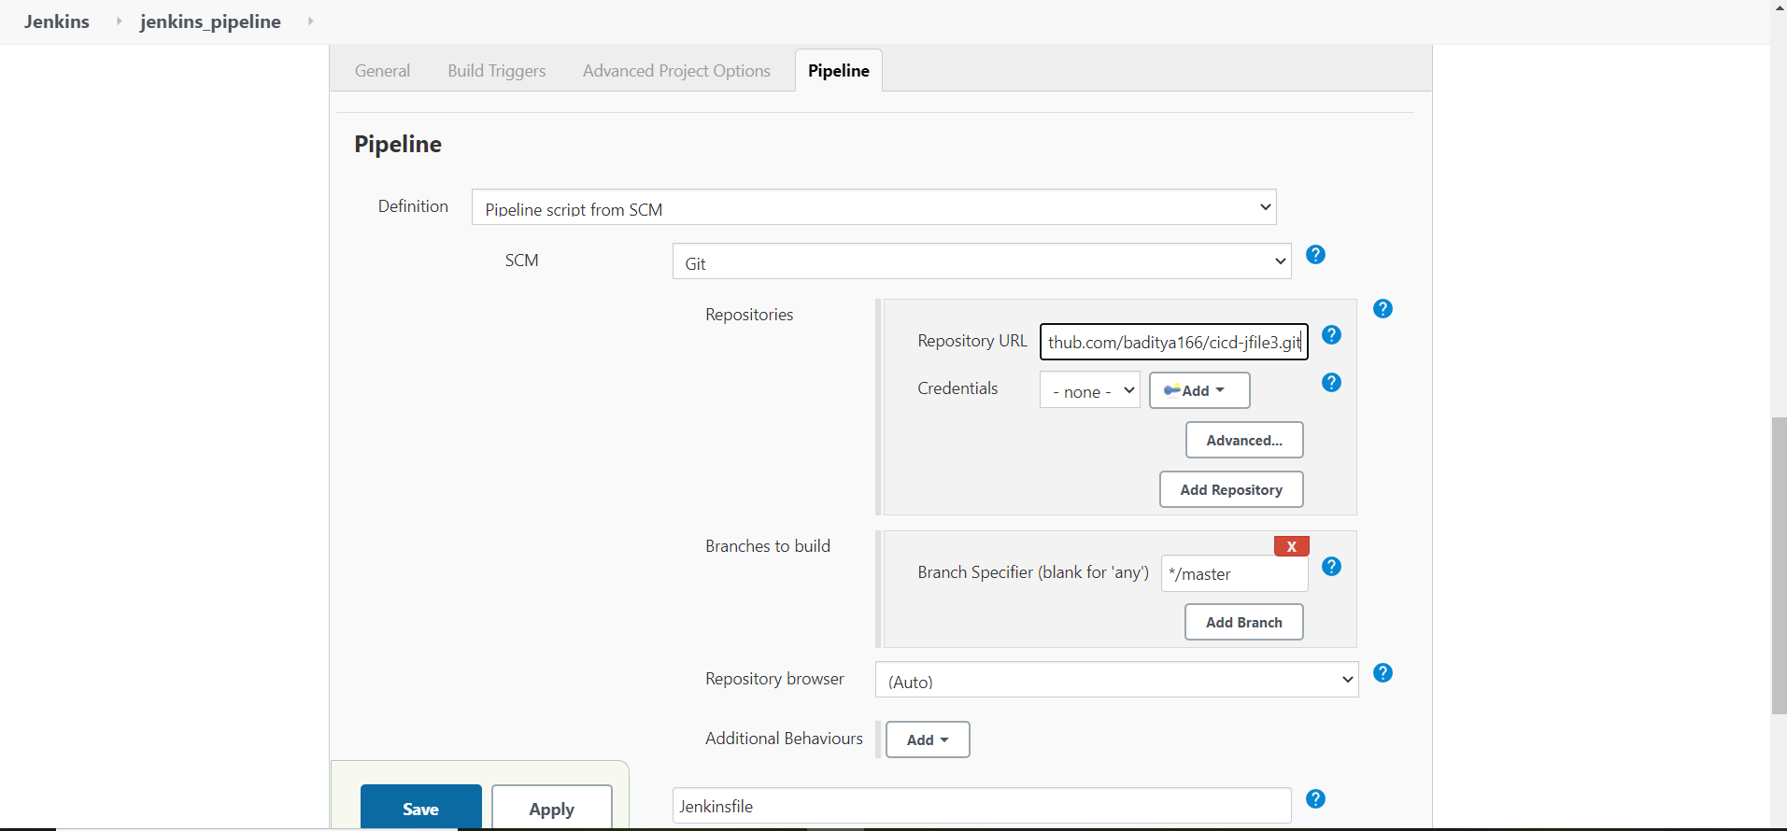

Check builds

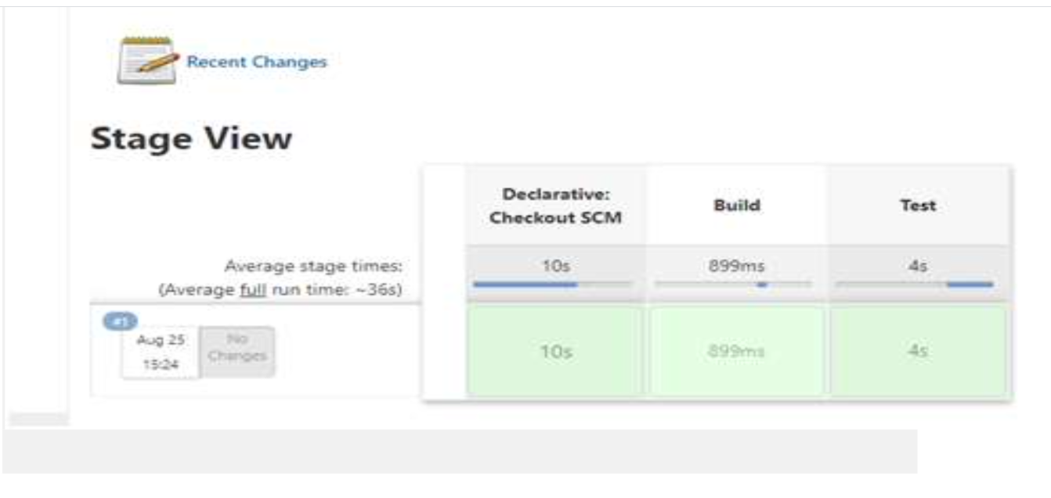

Console ouput

